Throughput Accounting

**Question 1**

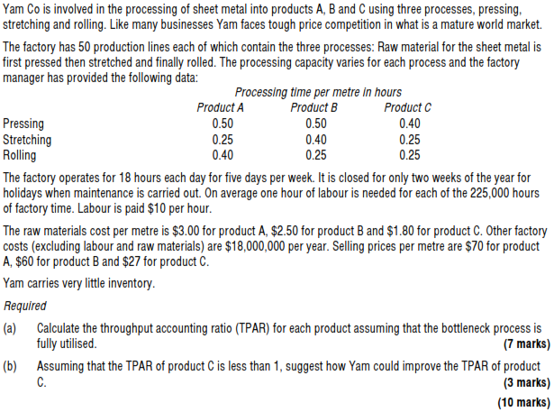

|  |  |  |
| --- | --- | --- |
| 1. |  |  |
|  |  |  |
| 2. |  |  |
| 3. |  |  |
|  |  |  |
| 4. |  |  |
|  |  |  |
| 5. |  |  |
|  |  |  |
| 6. |  |  |
|  |  |  |
| 7. |  |  |
|  |  |  |